Integration Manual
SpecterX Mail Protection Cloud Service: Configuration for Exchange Online



Introduction
This guide will walk you through the integration of SpecterX Mail Protection Cloud Service with Microsoft Exchange Online. SpecterX enhances the security of your organization’s email communications, ensuring compliance with data protection regulations and protecting sensitive information from external threats.

With this setup, outgoing emails that are flagged or meet specific protection criteria will be routed through the SpecterX Mail Protection Server. This adds an advanced layer of security before the emails are delivered, without disrupting your current email workflow. The SpecterX Mail Protection Cloud Service integrates seamlessly into your existing email infrastructure, offering scalable protection, visibility, and control.

Additionally, we will guide you through configuring rules for explicit users and groups. This ensures that emails sent by certain users or groups are automatically protected by SpecterX, helping maintain security across key individuals and teams.

*** Remember to consult with your system administrator or IT department if you encounter any issues or if this configuration impacts other systems.

Exchange Online Outbound and Inbound Connectors

Configure an Outbound Connector for SpecterX Mail Protection Server
- Login to your Exchange Online
- Login to the Office 365 Admin Center. Visit the URL https://admin.microsoft.com and enter your Office 365 admin account credentials.
- Access the Exchange Admin Center. In the Office 365 Admin Center, locate and select "Exchange" under "Admin Centers".
- Open Mail Flow - In the Exchange Admin Center, go to the "Mail Flow" category located in the left-hand menu.
- Create New Outbound Connector - Within Mail Flow, choose "Connectors" and click on the "+" button to create a new connector.
- Continue to set value step-by-step
- ‘New Connector’
Connection from = “Office 365”
Connection to = “Your Organization email server”
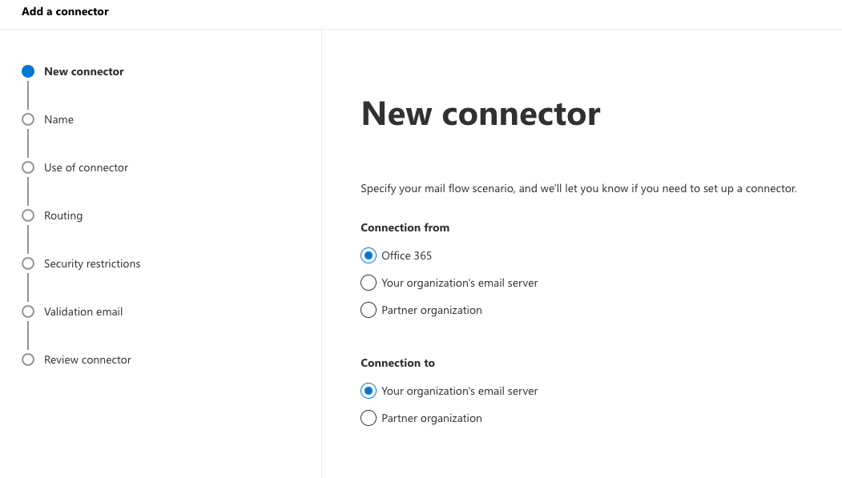

- Name
Name = Outbound Connector to SpecterX MPS 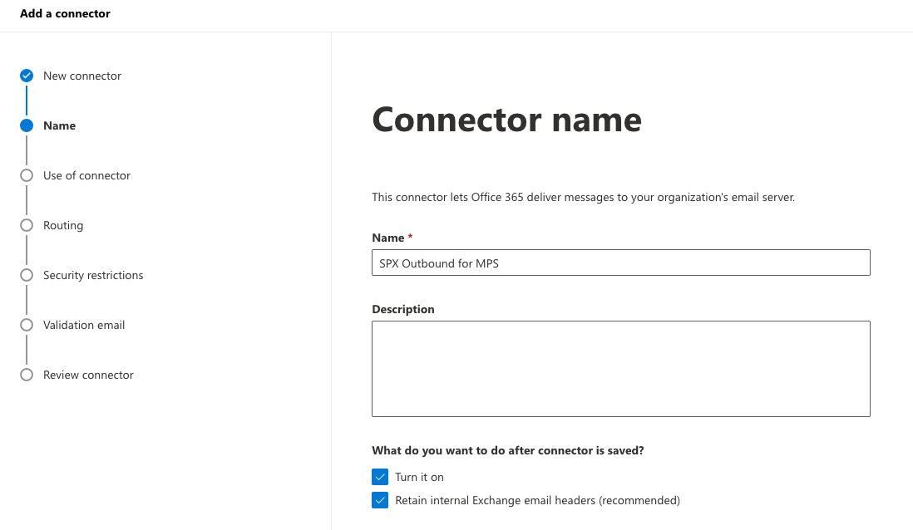

- Use of connector
Choose “Only when I have a transport rule set up that redirects messages to this connector”

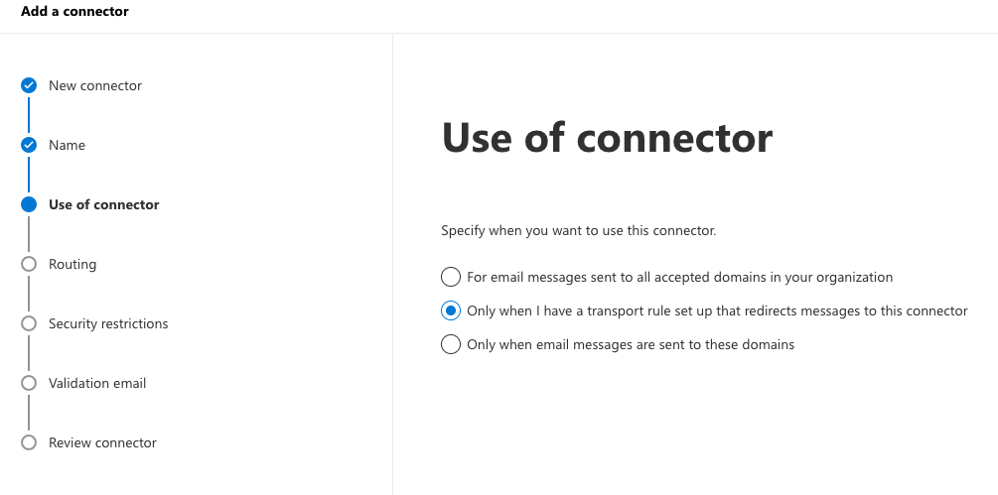
- Routing
Add the IP address of the SpecterX MPS service given to you by the SpecterX provider.

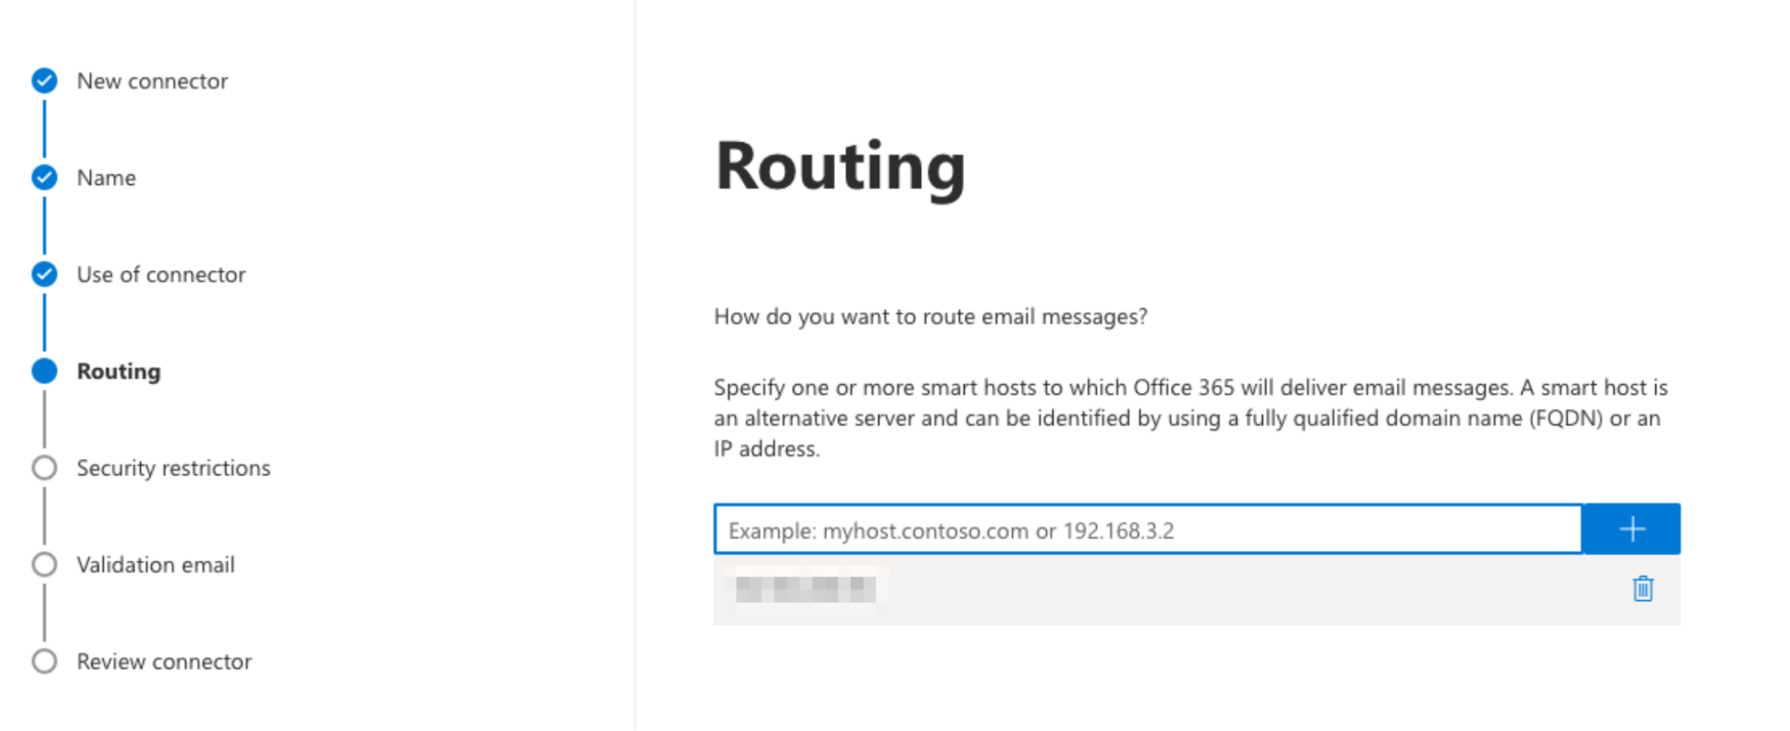
- Security Restrictions
Leave as is.
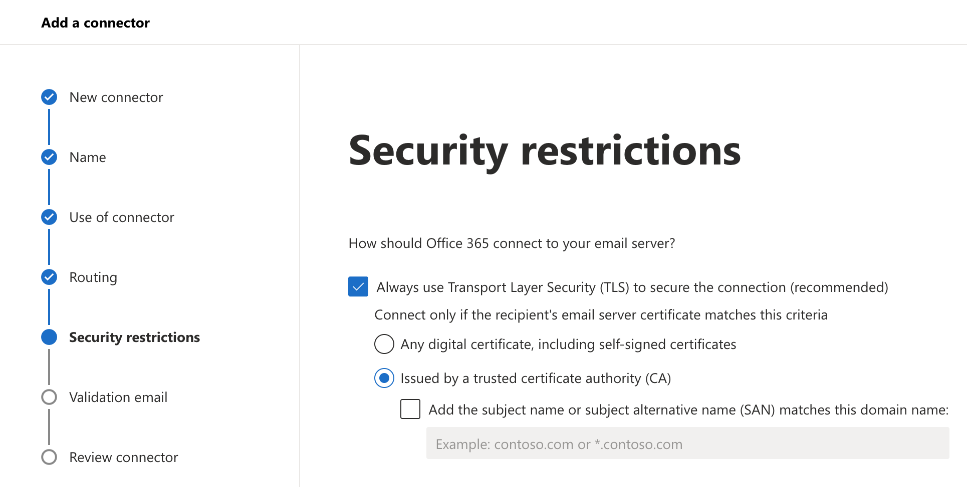
- Validation email
Enter your own organizational user email for test purposes.
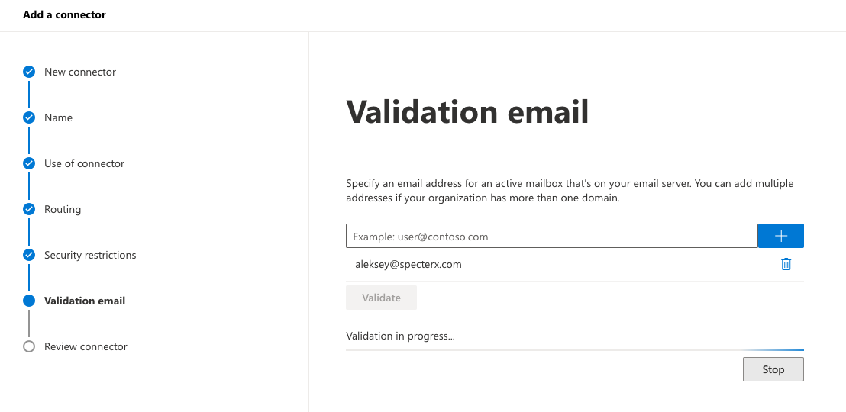
* In some cases, validation may fail at the validation step ->You may continue the process anyway.

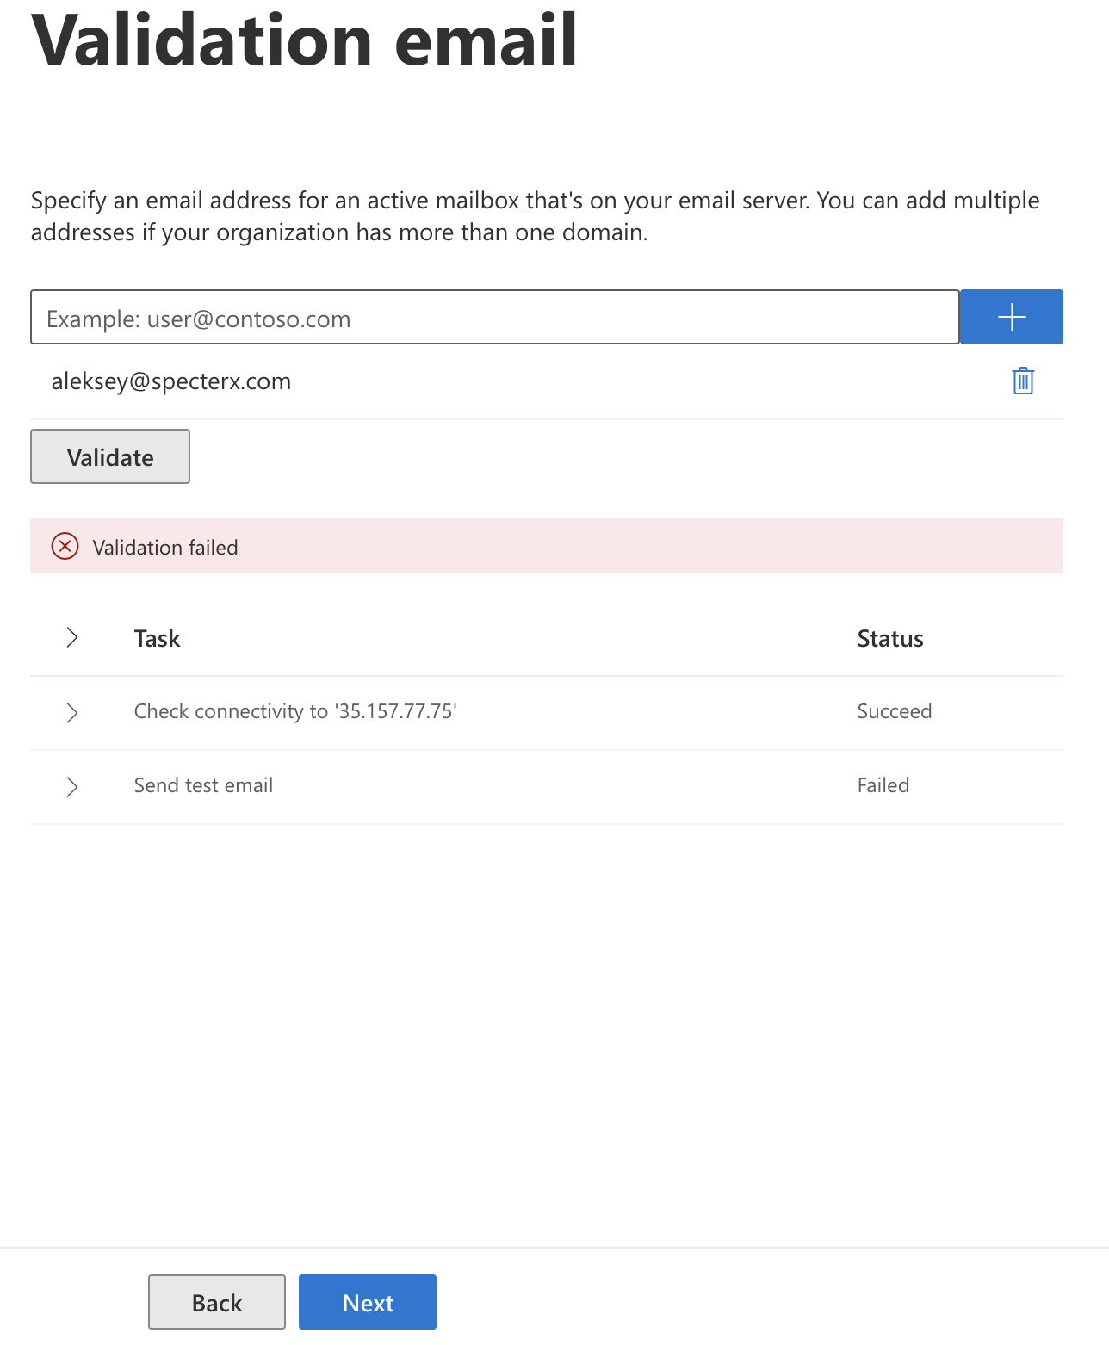
- Review and create your outbound connector. 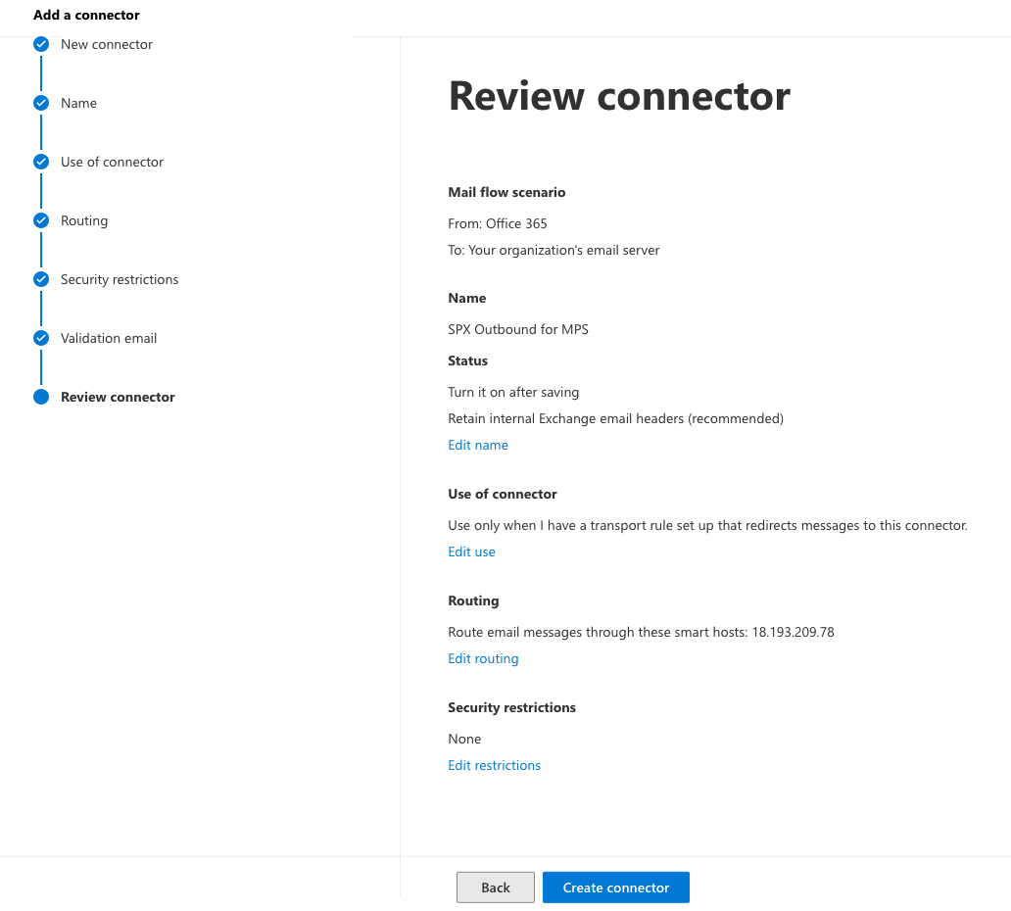

Exchange Online inbound connector setup for the SpecterX MPS
- New Connector->Connection from “Your Organization’s email server”->Connection to “Office 365”

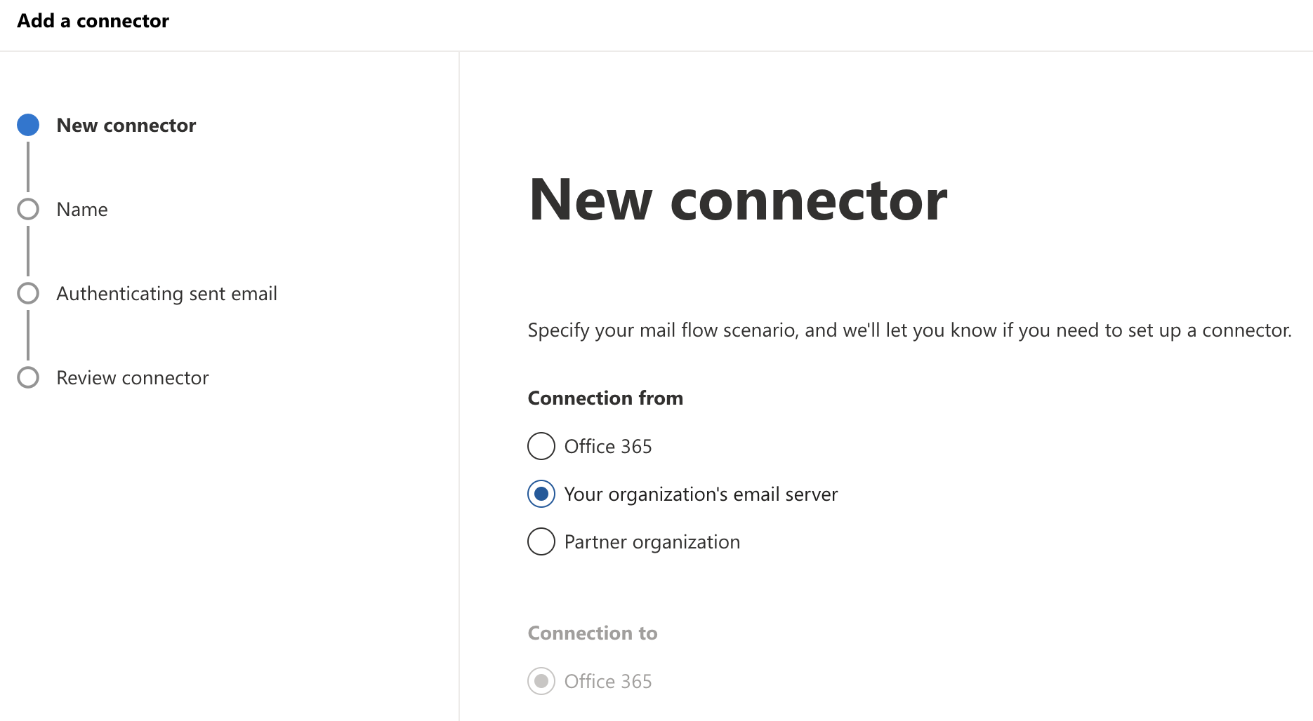
- Connector Name “SPX inbound for MPS” 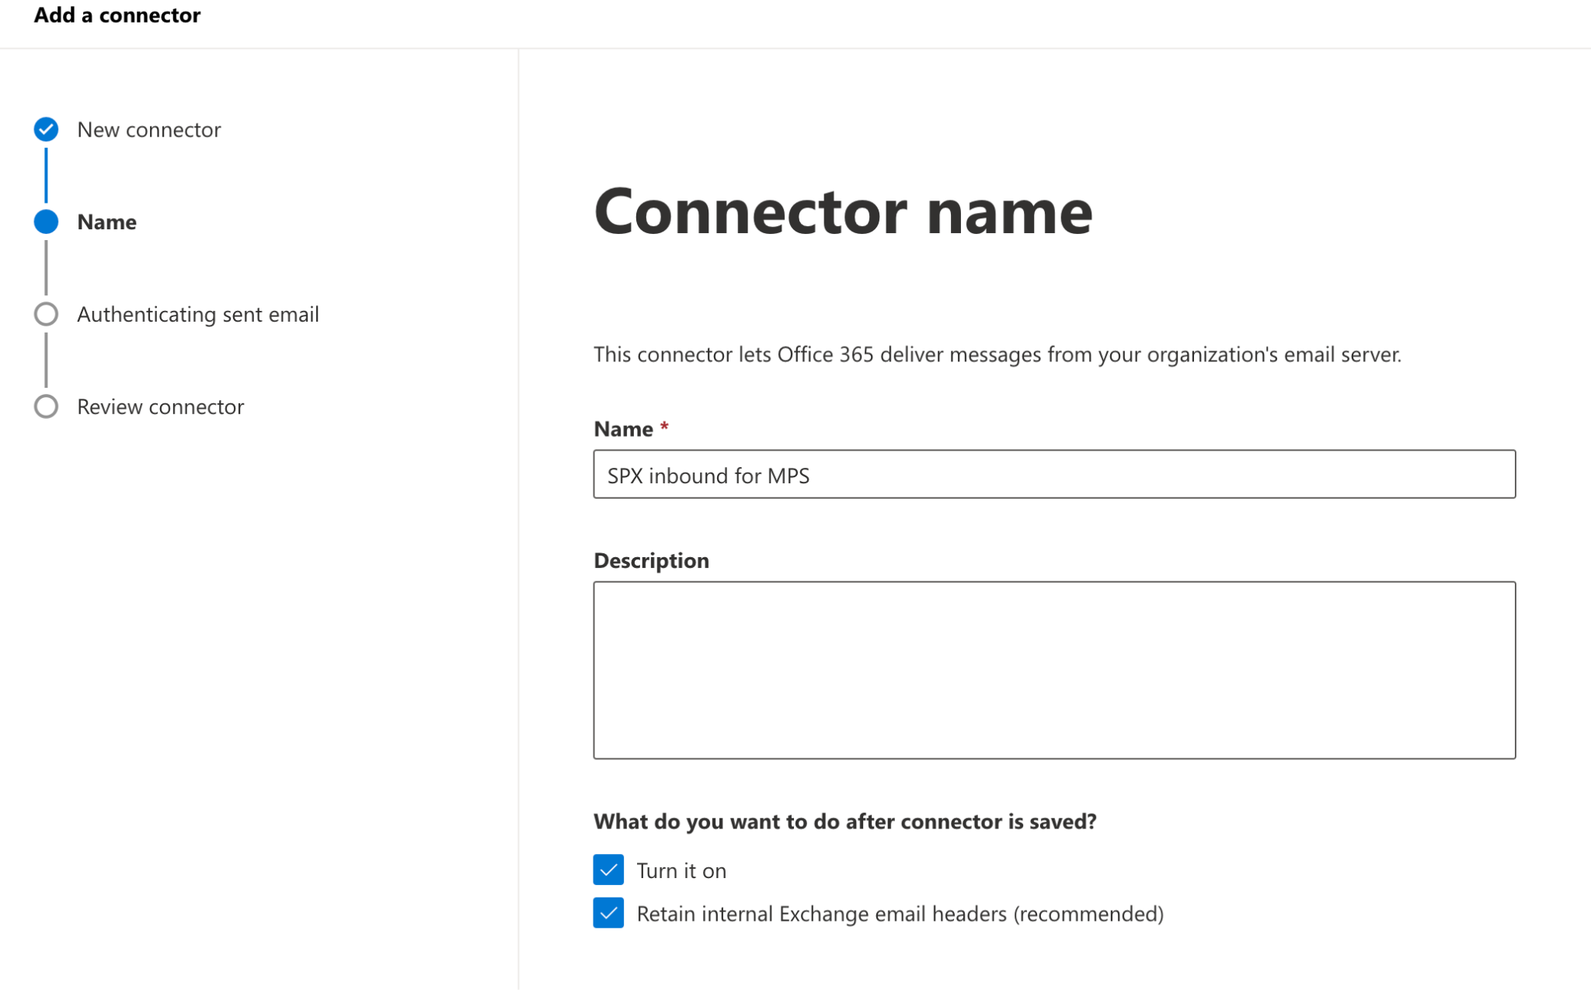
- Add your SpecterX Cloud MPS service provider IP address
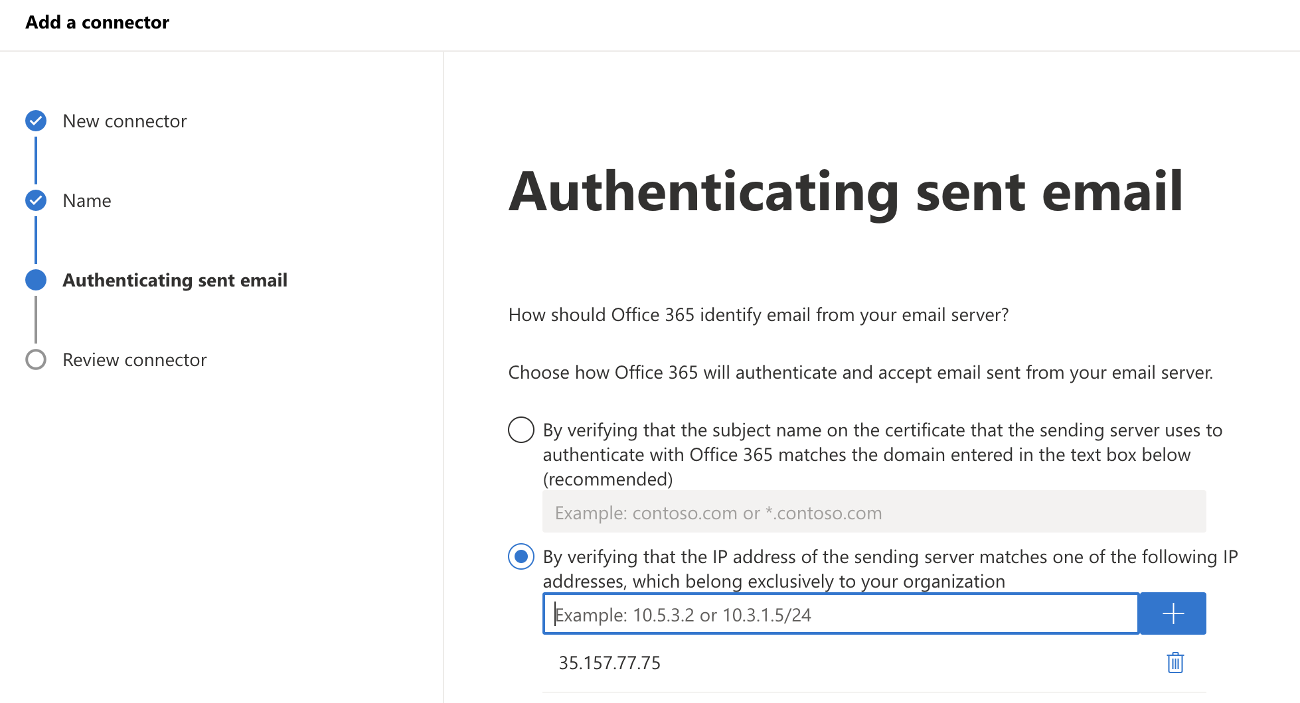

4. Review and Create your inbound connector.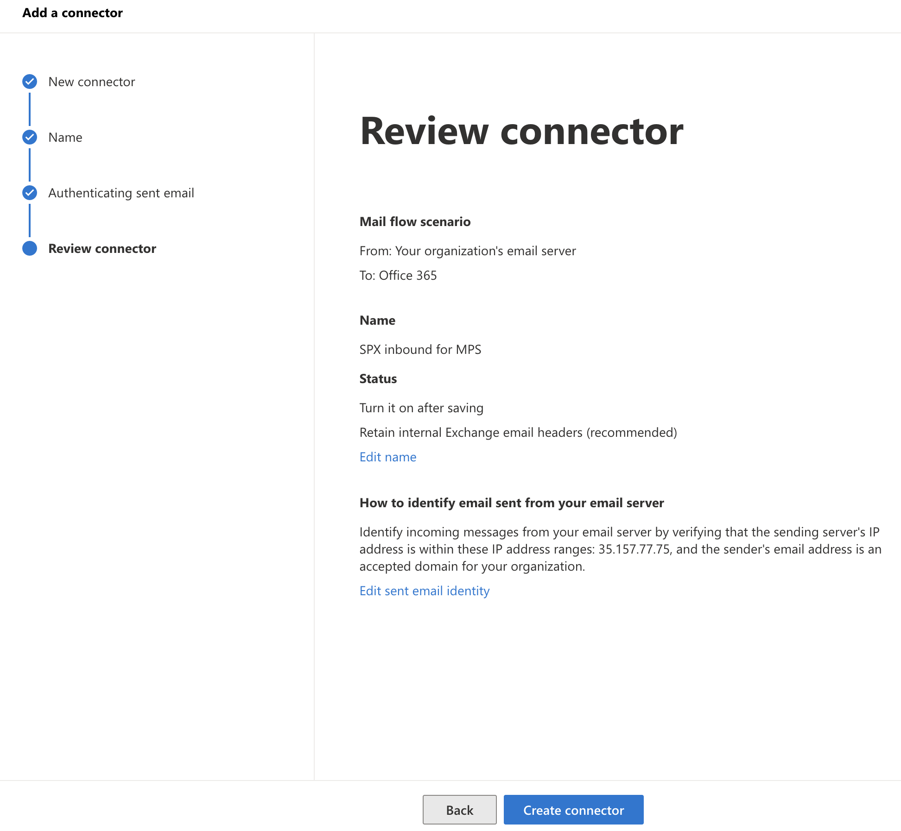

Exchange Online rules for the SpecterX MPS

Defining an Exchange Online rule for the SpecterX Outlook Add-in
These rules guide Exchange Online to pass emails to SpecterX MPS depending on the security status set by the SpecterX Outlook Add-in.

- Name - Create a new rule and name it “SpecterX Enforcement with Outlook Add-in”
- Apply this rule if - Set “Apply this rule if” to “The message headers” - “matches these text patterns”.
Then set the header key to x-specterx-policy and the value to “ey“
Note that the apostrophes in the attached screenshot were added by the Exchange wizard. You don’t need to use apostrophes when inserting the value.
- Do the following - Set “Do the following” to “Redirect the message to” - “the following connector”, and select the Outbound rule we created in the previous step.
- Except if - To avoid a loop (sending an already protected to SpecterX MPS over and over again), we need to set an expectation rule.
Set “Except if” to “The message headers” - “matches these text patterns”.
Then set the header key to x-specterx-policy and the value to protected.

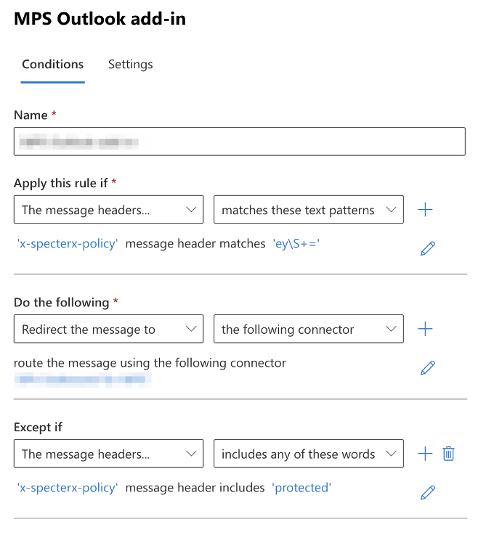

Defining an Exchange Online rule for Explicit Group\s
In case you want to set SpecterX MPS enforcement to work automatically for certain users or groups, follow these steps:

- Name - Create a new rule and name it “SpecterX Automatic Enforcement”
- Apply this rule if - Set “Apply this rule if” to any user or group you want to have their emails protected automatically, for every email they send.
In this example we added “teams”. That means that anyone in this group that sends an email, will have this email protected by SpecterX MPS.
- Do the following - Set “Do the following” to “Redirect the message to” - “the following connector”, and select the Outbound rule we created in the previous step.
- Except if - To avoid a loop (sending an already protected to SpecterX MPS over and over again), we need to set an expectation rule.
Set “Except if” to “The message headers” - “matches these text patterns”.
Then set the header key to x-specterx-policy and the value to protected.
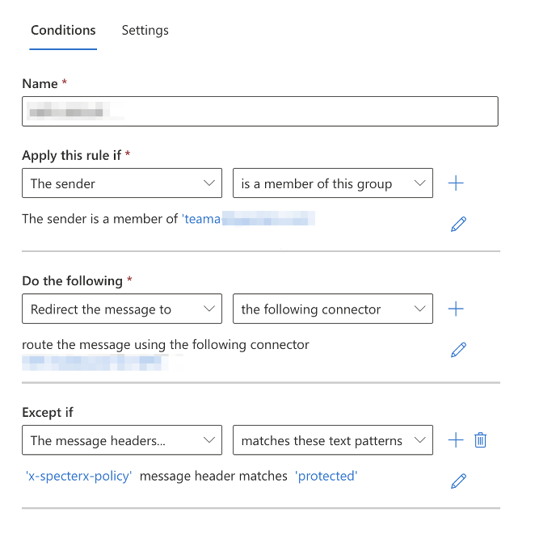

You’ve successfully configured the SpecterX Mail Protection integration with Microsoft Exchange Online. Outgoing emails that meet the specified criteria will now be securely routed through SpecterX for additional protection. Should you encounter any issues or need further assistance, feel free to reach out to our support team at support@specterx.com.

